

**TPO Solutions Delivery Proposal**

Woodside Phase 2 TCoE Implementation

November 2017

Version 2.0

**Contents**

1. Document Control 3

Authoring 3

Version History 3

Distribution List 3

2. Purpose of the Document 4

3. Test Process Optimisation Review Outcome 4

4. Conclusions 5

Recognition 5

Greater Efficiency 5

Start 5

Quick Wins 5

Tools 6

Coverage 6

Detailed Report 6

5. Optimisation Delivery Plan 7

6. Detailed Deliverables and Capability Uplift 8

7. Implementation Resources 12

8. Implementation Cost Model 13

9. Terms and Conditions 14

10. Appendix A -Phased Approach & Costings 15

10.1 Phase 1 Optimisation Delivery Plan 15

10.2 Phase 1 Implementation Cost Model 16

10.3 Phase 1 Implementation Proposed Resource’s and Schedule 17

11. Acceptance 18

# Document Control

## Authoring

|  |  |
| --- | --- |
| **Date** | Nov 2017 |
| **Author** | Jason Stannage, Kevin Chapman |
| **Email** | [jstannage@planittesting.com](mailto:jstannage@planittesting.com), kchapman@planittesting.com |

## Version History

|  |  |  |
| --- | --- | --- |
| **Version** | **Date Issued** | **Comments** |
| 2.0**Author** | 09/11/2017 | Initial Draft |
|  |  |  |
|  |  |  |
|  |  |  |

## Distribution List

|  |  |
| --- | --- |
| **Name** | **Title / Responsibility** |
| Ling Heang | Business Consultant IS&S Applications |
| Allison Blaber | Business Consultant IS&S Applications |
|  |  |
|  |  |

# Purpose of the Document

Following on from Phase 1 of the TCoE implementation which delivered a comprehensive test framework with supporting test processes reflecting a Bi-Modal (Waterfall/Agile) methodology and underpinned by strategic test assurance artefacts and guidelines. This was based on the recommendations contained within the Test Process Optimisation report (***attached on page 6***).

The purpose of this document is to define the outcomes, deliverables, capability uplift and milestones for these solutions for phase 2. In addition, it will document the proposed Phase 2 implementation plan, the resource types to underpin it and the estimate required to deliver these with an overall costing.

The Phase 2 overall costing is based on Woodside implementing all proposed Phase 2 solutions. It may be possible to deliver a subset of outcomes based on Woodside’s current appetite for change.

The Phase 2 proposal can be found in ***Appendix A***. We have left the remaining of this document in full from the original finding and full proposal for context and completeness.

# Test Process Optimisation Review Outcome

The TPO review of Woodside’s testing maturity showed that Woodside has a motivated team who are willing to change and improve. Speaking to many of the interviewees it became clear that historically Woodside has been overly reliant on highly engaged and diligent individuals who ensured that application quality was maintained. This often relied on the high level of Woodside experience of the systems involved rather than a repeatable, reliable, efficient and scalable testing approach. With the latest transition to an outsourced vendor delivery model, this experience and knowledge has largely been lost. This change of resources involved in testing has further exacerbated the lack of process.

The biggest challenge for delivering testing and quality assurance to the various projects and BAU changes in Woodside is the lack of a consistent and standardised test framework and approach that delivers measurable quality testing to the organisation. Although some SAP projects follow a more rigorous test approach, the majority of the projects have no clear guidelines or framework to deliver against. Certain aspects of the testing process/framework are relatively more mature and yet other aspects require attention. Woodside’s resource model of using contractors and vendors coupled with a lack of standard documentation and cross-portfolio lessons learnt sharing leads to duplication of effort and increased costs.

Planit have identified a series of key recommendations and improvement initiatives that, if implemented, will allow Woodside to establish an efficient, effective and rigorous Testing Centre of Excellence to drive quality outcomes across technology/software based projects.

The conclusions of the TPO Report, which were used to drive the optimisation delivery strategy, are listed below.

# Conclusions

## Recognition

Firstly, it should be recognised that despite the limitations identified in the preceding sections there is a strong commitment and willingness within Woodside digital team to embrace change to embed effective testing and quality assurance practices. The recommendations provided are designed to help deliver more efficient testing, to enable both reduced costs, increase and embed quality.

## Greater Efficiency

To help delivery greater efficiency with minimal risk and a sustainable approach, we believe that Woodside needs to focus on progressing from the current non-standardised approach across the organisation (level “Starting”) to at a minimum a managed and repeatable position (“Controlled & Measured”). In areas of particularly high value such as reporting and test automation, the target level should be set at Level B to align with Woodside’s digital strategy.

We recommend establishing a formal review of the TPO improvement activities in 12 months’ time to assess the progress to higher maturity. This will give Woodside direct feedback on the achievements made which can be then measured against the anticipated improvements based on this study.

## Start

We recommend that Woodside immediately invest in putting in place an interim TCoE, developing and implementing a test policy and framework and test strategy, including a comprehensive suite of processes, guidelines, checklists and approaches. This will provide the organisation with a target of how things should be done and will be trialled on selected proof of concept projects to gather fast feedback.

Once fully established, these improvements can then be used for communication to projects, vendors, contractors and business departments. At the very least, Woodside will develop a common toolset and language, which will be the first step to having everyone working together in synergy. Without this clear and comprehensive target, it will be impossible to successfully implement any of the other recommendations contained in this report.

## Quick Wins

The definition of a test strategy and proper test planning will enable many of the other recommendations to be formalised and proposals discussed and reviewed among Woodside’s stakeholders. Most of the quick wins will flow directly from this.

Implementing a TCoE and testing framework is a major quick win for Woodside. The TCoE will enable the standardisation of testing across the organisation through templates and socialising of a formalised process, getting double gains from the quick win. The framework will provide a means of propagating the changes across Woodside and embedding the changes across project and BAU changes, regardless of the delivery methodology or technology.

Embedding quality throughout the delivery cycle is a major quick win for Woodside as the move shifts the focus from defect detection to defect prevention. This also enables Woodside to better set expectations on testing outcomes and deliverables from vendors and effectively manage this process.

## Tools

An area that can bring noticeable efficiency gains for Woodside is the configuration and standardisation of Woodside approved test management tools. Once an agreed and consistent test policy and framework has been established, the Woodside ALM instance should be modified to align with this new approach.

Test automation is currently a black box for Woodside, with vendors making all tooling related decisions. A quick win here is to educate and coach Woodside staff on test automation basics and approaches to enable them to have smart conversations with technology partners on appropriate tool selection. Created test automation assets will be tracked and re-used as part of the testing framework and the return on investment monitored and reported on.

## Coverage

Once the test management toolsets have been enhanced to align with the new test policy and framework, it will be possible to see and report against test requirement coverage. Once the test requirements coverage is understood, it will be possible to produce quality driven metrics to allow Woodside to make informed decisions on project quality. There is also potential to reduce the number of test cases associated with each project without increasing the risk of issues in production. This will reduce effort not only of execution, but also of maintenance and management.

## Detailed Report

The full TPO report produced by Planit which provides a lower level of detail on the quality initiatives and the issues this will address can be accessed below:



*Please note the initial report had not taken into consideration a phased implementation. Subsequent changes made to facilitate a multiple phased delivery have superseded the original implementation approach and are reflected within this document under Appendix (A).*

# Optimisation Delivery Plan

The plan below articulates the detailed activities required to deliver the recommended optimisation initiatives. Each item has been given a unique identifier (e.g. KA16a) which can be cross-referenced back to the detailed recommendation in the TPO report embedded in the section above.

Quick wins and strategic coaching sessions have been specifically identified in this plan for visibility.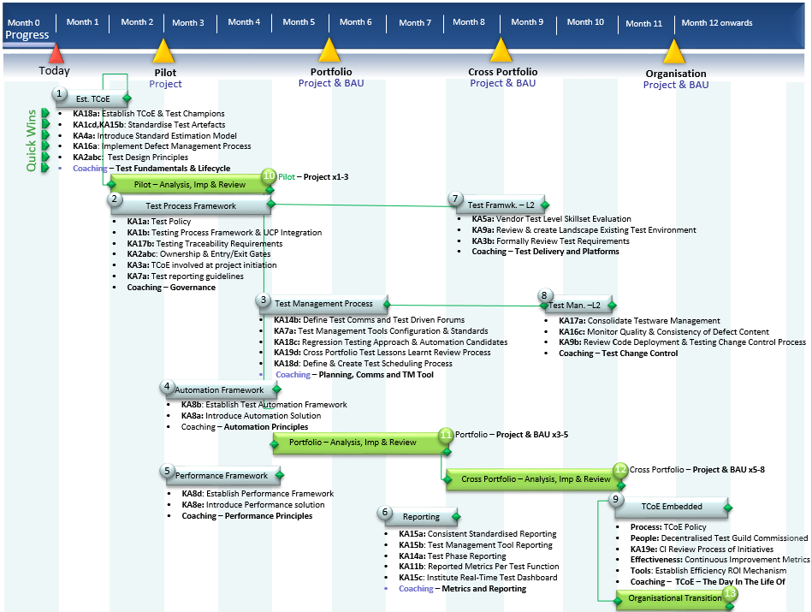

Planit have provided a suggested implementation roadmap as requested, however this should be refined when greater context of Woodside’s delivery model is understood.

These stages facilitate change at Woodside’s cadence and provide an indicative logical sequence to the implementation. The aim is to establish an improvement foundation that drives the process and quality accelerators in order to deliver maximum benefit in the quickest time.

It is imperative that while defining and implementing the strategic improvement initiatives, there is a project delivery mechanism to channel change and provide essential feedback on the effectiveness of the initiatives. At each phase, validation points are in place to manage progress while getting the benefit from the optimised deliverables on emerging inflight projects.

Please find attached a PDF version of the optimisation delivery plan:



# Detailed Deliverables and Capability Uplift

The following table details the required deliverables for each milestone and the associated capability uplift that will be realised for Woodside.

| **Outcome** | **Deliverables** | **Capability Uplift** |
| --- | --- | --- |
| **Milestone:** Month 1-2  **Quick Wins** | **Summary**  The creation of a Testing Centre of Excellence (TCoE) is the first initiative that Planit is recommending. The remit of the TCoE would be to set the agenda, framework and governance for testing and quality assurance within Woodside. It will present a single engagement point and voice for these services. The TCoE will be accountable for defining and rolling out a test policy across Woodside, standardising testing templates and artefacts (including continuous review of use), and coaching and training for testing champions within Woodside.  The TCoE will be a driver of testing maturity within Woodside. Once the other initiatives have been embedded and are delivering results, its functions distributed to identified stakeholders, it will then be an established Woodside’s Testing Centre of Excellence.  **Deliverables (Quick Wins)**   * **KA18a:** Establish TCoE & Test Champions * **KA1cd, KA15b:** Standardise Test Artefacts * **KA4a:** Introduce Standard Estimation Model * **KA16a:** Implement Defect Management Process * **KA2abc:** Test Design Principles * **Coaching** – Test Fundamentals & Lifecycle | * Woodside has the ability to correctly assess timelines and effort required for testing. * Use of standardised testing templates to institute common test process. * Providing the understanding on what constitutes a robust and repeatable test case, ensuring both Woodside and vendor deliverables are of the required standard. * Standard test strategy provides the capability for Woodside to define the “how” of testing for a project – e.g. test types, test tools, resources, cycles required. * Standard test plan provides the capability for Woodside to define and measure the “what” of testing – e.g. document all in-scope and out of scope requirements and map to required test coverage. * Standard test summary report provides Woodside the capability to define the information needed to assess the overall quality of a deliverable and measure it against the success criteria. * Standard defect management process provides the ability to effectively manage change and provide a detailed audit trail to ensure data on which quality decisions is made is as accurate as possible. * Uplift key Woodside resource with fundamental testing knowledge. |
| **Milestone:** Month 2-4 | **Summary**  Following the establishment of a TCoE, it is recommended that Woodside create and implement a test framework that supports both traditional and agile delivery methods. The purpose of the framework is to embed quality into project/software delivery from day one, leveraging the artefacts produced by the TCoE to provide a standard set of testing processes, including a set of minimum required standards to be adhered to.  The Woodside test framework will design and implement testing standards, guidelines, processes and ownership capabilities. The framework delivered will integrate into and complement the existing Woodside Unified Change Process, focussed on managing and delivering to Woodside’s risk appetite. It will ensure that the level of testing is based on the business and organisational risk of the application or feature being delivered.  **Deliverables**   * **KA1a:** Test Policy * **KA1b:** Testing Framework & UCP Integration * **KA17b:** Testing Traceability Requirements * **KA2abc:** Ownership & Entry/Exit Gates * **KA3a:** TCoE involved at project initiation * **KA7a:** Test reporting guidelines * **Coaching** – Governance | * Woodside has the ability to make quality-based decisions based on detailed test reporting and linked requirements. * Application of minimum standard framework maximising re-use and minimising waste. * Codification of Woodside’s mission and objectives as they relate to testing. * Drive the earlier adoption of testing to drive out defects as early as possible, minimising cost and rework. * Knowing when to start or stop testing based on agreed criteria judged at the start or end of a testing activity. * Establishing ownership and accountability for testing activities providing certainty and clear lines of escalation. |
| **Milestone:** Month 4-6 | **Summary**  Implement a standard test management process that supports traditional and agile delivery across projects and BAU. This will enable Woodside to monitor and manage the effectiveness and cost of testing conducted internally or by vendor partners.  By implementing a minimum standards based test management process Woodside develops the capability to build meaningful and clear pictures of product/system quality at all stages of the delivery process that can be used for both vendor and internal projects.  Coupled with this is a program of work to identify and standardise the key Woodside test management tools to be used. Woodside testing tools will be configured to support the changes being made by the TCoE, particularly relating to test process, test metrics and test reporting.  The process will also standardise communications and meeting/forums for all those engaged or with a stake in the testing process.  **Deliverables**   * **KA14b:** Define Test Comms and Test Driven Forums * **KA7a:** Test Management Tools Configuration & Standards * **KA18c:** Regression Testing Approach, Automation Candidate * **KA19d:** Cross Portfolio Test Lessons Learnt Review Process * **KA18d:** Define & Create Test Scheduling Process * **Coaching** – Planning, Comms and TM Tool | * Woodside has the capacity to target testing related information at the correct level to the correct stakeholder. * Woodside endorsed test management tools are configured to capture all required testing MI to ensure that information is retained and reportable. This also minimises the effort required to capture testing MI. * Build the capability to implement the correct regression testing approach on an application by application basis. * Provide a process to maintain regression testing IP from projects to BAU and ensure that the suites are correctly maintained and updated in line with application changes. * Institute an organisational process to share testing lessons learned. * Efficiency and reliability of testing process can be measured and tracked due to standardised test scheduling process. |
| **Milestone:** Month 3-4 | **Summary**  To ensure that Woodside is able to leverage the best value from any automation services it engages, it is crucial to have a robust and rigorous model to support, manage and monitor these activities.  The model will include guidelines for appropriate tool selection, looking at value for money and technology/task appropriateness, clear standards to create and monitor automation testing, requirements and success criteria, and creating a model to ensure that, as far as possible, existing technology assets are re-used and updated.  **Deliverables**   * **KA8b:** Establish Test Automation Framework * **KA8a:** Introduce Automation Solution * **POC:** Tool /ROI * **Pilot:** Automate Key Application * **Coaching** – Automation Principles | * Capability created for Woodside to evaluate and recommend tooling solutions for projects to ensure fit-for-purpose tool solutions are implemented and there is significant ROI. * Woodside is able to identify suitable manual scripts that are appropriate to be automated. * Establish success criteria for automation solutions to ensure delivered outcome meets requirements. * Establishing a framework to maximise the benefit of any investment in automation through re-use in project and BAU contexts, continuous review and updating. |
| **Milestone:** Month 3-4 | **Summary**  To ensure that Woodside is able to leverage the best value from any performance testing services it is crucial to have a robust and rigorous model to support, manage and monitor these activities.  The model will include guidelines for appropriate tool selection, looking at value for money and technology/task appropriateness, clear standards to create and monitor performance testing, requirements and success criteria, and creating a model to ensure that, as far as possible, existing technology assets are re-used and updated.  **Deliverables**   * **KA8d:** Establish Performance Framework * **KA8e:** Introduce Performance solution * **POC:** Tool * **Review:** Performance Capability * **Coaching** – Performance Principles | * Woodside has the capability to review outcomes of performance testing and make informed decisions. * Capability created for Woodside to evaluate and recommend tooling solutions for projects to ensure fit-for-purpose tool solutions are implemented. * Woodside has the required level of knowledge to set testable and meaningful performance required to be tested against. * Establish success criteria for performance solutions to ensure the delivered outcome meets requirements. * Establishing a framework to maximise the benefit of any investment in performance testing through re-use in project and BAU contexts, continuous review and updating. |
| **Milestone:** Month 7-8 | **Summary**  Leveraging requirements traceability and the configuration of Woodside’s test management tools, a series of consistent test reporting templates will be developed and published with guidelines on how to create and interpret the information and a frequency time table for when the reports should be issued. These would be applicable for internal and vendor delivered projects.  After a period of review, a framework to report on testing information in real-time, via a dashboard system, will be implemented  **Deliverables**   * **KA15a:** Consistent Standardised Reporting * **KA15b:** Test Management Tool Reporting * **KA14a:** Test Phase Reporting * **KA11b:** Provide Visibility of Reported Metrics Test Function * **KA15c:** Institute Real-Time Cross Portfolio Test Dashboard * **Coaching** – Metrics and Reporting | * A consistent reporting template instituted across Woodside enabling meaningful testing information to be communicated. * The content of reports allows Woodside to make objective quality decisions throughout the lifecycle of a project/change. * Test reporting is generated from Woodside approved test management tools reducing the time spent on generation. * Reporting allows Woodside to ascertain the effectiveness of the various testing phases/functions. * The on-demand availability of testing MI empowers Woodside business stakeholders and testing champions. |
| **Milestone:** Month 8-9 | **Summary**  This is the secondary phase for the delivery of the Test Process framework.  Building on the foundations set in Outcome 2 (Test Process Framework), this phase will review and implement recommendations based on analysis of Woodside’s partner capabilities, test environment usage and limitations and requirements quality.  **Deliverables**   * **KA5a:** Vendor Test Level Skillset Evaluation * **KA9a:** Review & create Landscape Existing Test Env * **KA3b:** Formally Review Test Requirements * **Coaching** – Test Delivery and Platforms | * Woodside can objectively rate the quality of skills/outcomes provided by vendor partners. * Areas of improvement in partners can be identified and rectified resulting in an increase in quality of the delivered services. * Test environment conflicts, downtime, change impacts etc. are reduced as a result of establishing knowledge of overall test environment landscape. * Testing is built into project delivery from the requirements gathering stage. This a) enables Woodside to detect defects when they are cheapest to resolve and b) ensures that all requirements are testable. |
| **Milestone:** Month 9-10 | **Summary**  This is the secondary phase for the delivery of standard test management process that supports traditional and agile delivery across projects and BAU.  Building on the foundations set in Outcome 3 (Test Management Process), this phase will roll out a series of control and improvement measures across testware, defect quality and code/change control processes.  **Deliverables**  **KA17a:** Consolidate Testware Management  **KA16c:** Monitor Quality & Consistency of Defect Content  **KA9b:** ReviewCode Deployment & Testing Change Control Process  **Coaching** – Test Change Control | * All testing related IP and templates stored and organised in a common manner enabling ease of access. * Woodside TCoE resources can identify and work with vendors to remediate issues with the quality of information contained in defects. Poor information results in waste and duplication of effort. * Enhancement of existing change control process gives Woodside the ability to minimise defects detected that resulted from incorrect deployments and/or code configuration. * Streamlined deployment process maximises the time available to conduct testing activities. |
| **Milestone:** Month 10-12 | **Summary**  The final major initiative recommended is to establish the mechanisms for continuous improvement across the testing framework at Woodside. Crucial to this is the identification and monitoring of key performance indicators that can be used to measure the effectiveness of testing and any implemented changes. This will be leveraged by the test reporting and test management tool use described above.  The eventual end-point is for the Woodside Testing Centre of Excellence becoming a distributed and essentially self-service model.  **Deliverables**   * **Process:** TCoE Policy * **People:** Decentralised Test Guild Commissioned * **KA19e:** CI Review Process of Initiatives * **Effectiveness:** Continuous Improvement Metrics * **Tools:** Establish Efficiency ROI Mechanism * **Coaching** – TCoE – The Day In The Life Of | * Woodside TCoE and Testing Guild can effectively manage internal testing functions and all vendor testing requirements and deliverables. * Woodside can successfully articulate the return on investment from testing activities. * The value of testing can be articulated and is recognised across Woodside. * Testing knowledge embedded in Woodside TCoE and Guild enables the existing testing process to be measured and improved against agreed metrics. |
| **Milestone:** Month 2-4    **Milestone:** Month 5-7  **Milestone:** Month 8-10    **Milestone:** Month 11-12 | **Pilot Phase Summary**  It is imperative that while defining and implementing the strategic improvement initiatives, there is a project delivery mechanism to channel change and provide essential feedback on the effectiveness of the initiatives.  The pilot phase has been designed to deliver the above feedback, upskill Woodside resources using practical project examples and to embed quality at the earliest possible opportunity. This is a scalable and logical approach based on a structured roll out across targeted projects.  At each pilot project phase, validation points are in place to manage progress while getting the benefit from the optimised deliverables on emerging inflight projects.  **Deliverables**   * **Pilot:** [**1-3** Projects] * - (**1**) Est.TCoE * - (**2**) Test Process Framework (%) * **Portfolio:** [**3-5** Projects & BAU] * **-** Pilot Deliverables * **-** (**2**) Test Process Framework * **-** (**3**) Test Management Process (%) * **-** (**4**) Automation Framework * **-** (**5**) Performance Framework * **Cross Portfolio:** [**5-8** Projects & BAU] * **-** Pilot and Portfolio Deliverables * **-** (**3**) Test Management Process * - (**6**) Reporting Standardisation * - (**7**) Bi-Modal Framework L2 * - (**8**) Test Management Process L2 * **Organisational Transition:**  All Project and BAU * **-** Pilot, Portfolio & Cross Portfolio Deliverables * - (**9**) TCoE Embedded * **Inflight Coaching**: Across the entire implementation | * Practical application of testing standards and principles on live projects. * Training and knowledge upskilling of Woodside resources made more efficient through working with real-world examples. * Woodside projects instantly benefit for increased rigour and management of testing, driving greater value from vendor partners. * Adoption of TCoE practices on projects drives the capture of feedback so lessons learned can be reported on and actioned early in the rollout. * Pilot projects enables equivalent upskilling and benefits realisation between both project and BAU testing activities. * Planned expansion of pilot scope prevents testing knowledge from siloing and uplifts capability across Woodside portfolios**.** |

# Implementation Resources

The four key roles required to deliver on the above initiatives are detailed below.

| **Role Title** | **Key attributes and experience** | **High-level delivery responsibilities** |
| --- | --- | --- |
| **Strategic Test Manager (STM)** | The Strategic Test Manager works with clients at a strategic level, providing strong leadership and management to large, complex or distressed projects when required. They undertake test process improvement initiatives, tool evaluation, test audits and workshops and play a key role in relationship management of our accounts.  **Experience:** 22 years’ minimum testing experience, experience with managing multiple complex projects. | * Deliver quality initiatives as per implementation plan * Mentoring and coaching of Woodside resource * Roadmap delivery * Stakeholder management |
| **Test Delivery Manager (TDM)** | The Test Delivery Manager develops and leads large teams across significant or multiple programs of work. They assess risk and determine optimum risk reduction plans. They are experienced at negotiating with vendors and suppliers to ensure testing deliverables are met. They create test strategies and test plans at either the program, project or test-phase level and can report at all levels within a client organisation.  **Experience:** 18 years’ minimum testing experience, multiple domain knowledge and project test management - leading and managing projects. | * Project-based implementation * Feedback monitoring and rework * Testing change champion * Supporting delivery of quality initiatives |
| **Technical Test Delivery Manager (TTDM)** | The Technical Test Delivery Manger develops solutions, lead large teams across significant or multiple programs of work. They assess risk and determine optimum risk reduction plans. They are experienced at negotiating with vendors and suppliers to ensure technical testing deliverables are managed and met. They create and implement technical test strategies, test plans and toolset implementations at either the organisational, program, project or test-phase level.  **Typical Experience:** 8 years’ testing experience, multiple domain knowledge and tool accreditations. | * Review of test automation and performance implementations and deliverables * Mentoring and coaching in automation/performance tooling and delivery methods |
| **Woodside Business Consultant (WBC)** | As per existing Woodside Business Consultant experience. | * Target project identification * Testing framework in UCP * Testing/business interface * Promotion of testing capabilities * Act of Woodside Test Champion |

# Full Implementation Cost Model

The table below articulates the full costing per outcome, on a resource basis, to deliver this proposal.

| **Outcome** | **Resource Type** | **No of days** | **Daily Rate**  **(Exc. GST)** | **Cost $ AUD**  **(Exc. GST)** |
| --- | --- | --- | --- | --- |
|  | Strategic Test Manager/Test Delivery Manager | 47 (25/22) | $/$ | $ |
| Woodside Business Consultant | 10 | N/A | N/A |
|  | Strategic Test Manager/Test Delivery Manager | 81  (55/26) | $/$ | $ |
| Woodside Business Consultant | 27 | N/A | N/A |
|  | Strategic Test Manager/Test Delivery Manager | 66  (45/21) | $/$ | $ |
| Woodside Business Consultant | 24 | N/A | N/A |
|  | Technical Test Delivery Manager | 48 | $/$ | $ |
| Woodside Business Consultant | 5 | N/A | N/A |
|  | Technical Test Delivery Manager | 28 | $ | $ |
| Woodside Business Consultant | 5 | N/A | N/A |
|  | Strategic Test Manager/Test Delivery Manager | 33  (25/8) | $/$ | $ |
| Woodside Business Consultant | 7 | N/A | N/A |
|  | Strategic Test Manager/Test Delivery Manager | 41  (30/11) | $/$ | $ |
| Woodside Business Consultant | 15 | N/A | N/A |
|  | Strategic Test Manager/Test Delivery Manager | 23  (15/8) | $/$ | $ |
| Woodside Business Consultant | 5 | N/A | N/A |
|  | Strategic Test Manager/Test Delivery Manager | 32  (28/4) | $/$ | $ |
| Woodside Business Consultant | 19 | N/A | N/A |
|  | Test Delivery Manager | 110 | $ | $ |
| Woodside Business Consultant | TBC | N/A | N/A |
| **Total Woodside Resource** | Woodside Business Consultant | 117 | N/A | NA |
| **Total Planit Resource Cost** | Strategic Test Manager | 223 | $ | $ |
| Test Delivery Manager | 210 | $ | $ |
| Technical Test Delivery Manager | 76 | $ | $ |
| Planit have provided discounted rates for all resources detailed in the cost table as follows:   * **Strategic Test Manager Std. Daily Rate:** $+GST, Woodside Rate $+GST (% discount) * **Test Delivery Manager Std. Daily Rate:** $+GST, Woodside Rate $+GST (% discount) * **Technical Test Delivery Manager Std. Daily Rate:** $ +GST, Woodside Rate $+GST (% discount)   Based on these discounts these provide Woodside a total value proposition saving of **$+GST (% discount)** | | | **Total Cost (Exc. GST)** | **$** |
| **Total Cost (Inc. GST)** | **$** |

# Appendix A –Phase 2 Approach & Costings

## 10.1 Phase 2 TCoE Optimisation Delivery Plan

The plan below articulates the detailed activities required to deliver the recommended optimisation initiatives that are scheduled to form Phase 2. Each item has been given a unique identifier (e.g. **KA16a**) which can be cross-referenced back to the detailed recommendation in the TPO report embedded in the section above.

Phase 1 completed deliverables has been highlighted in [**Green**] for completeness.

The deliverables planned for phase 2 and the associated strategic coaching sessions have been specifically identified in this plan for visibility and highlighted in [**BOLD**].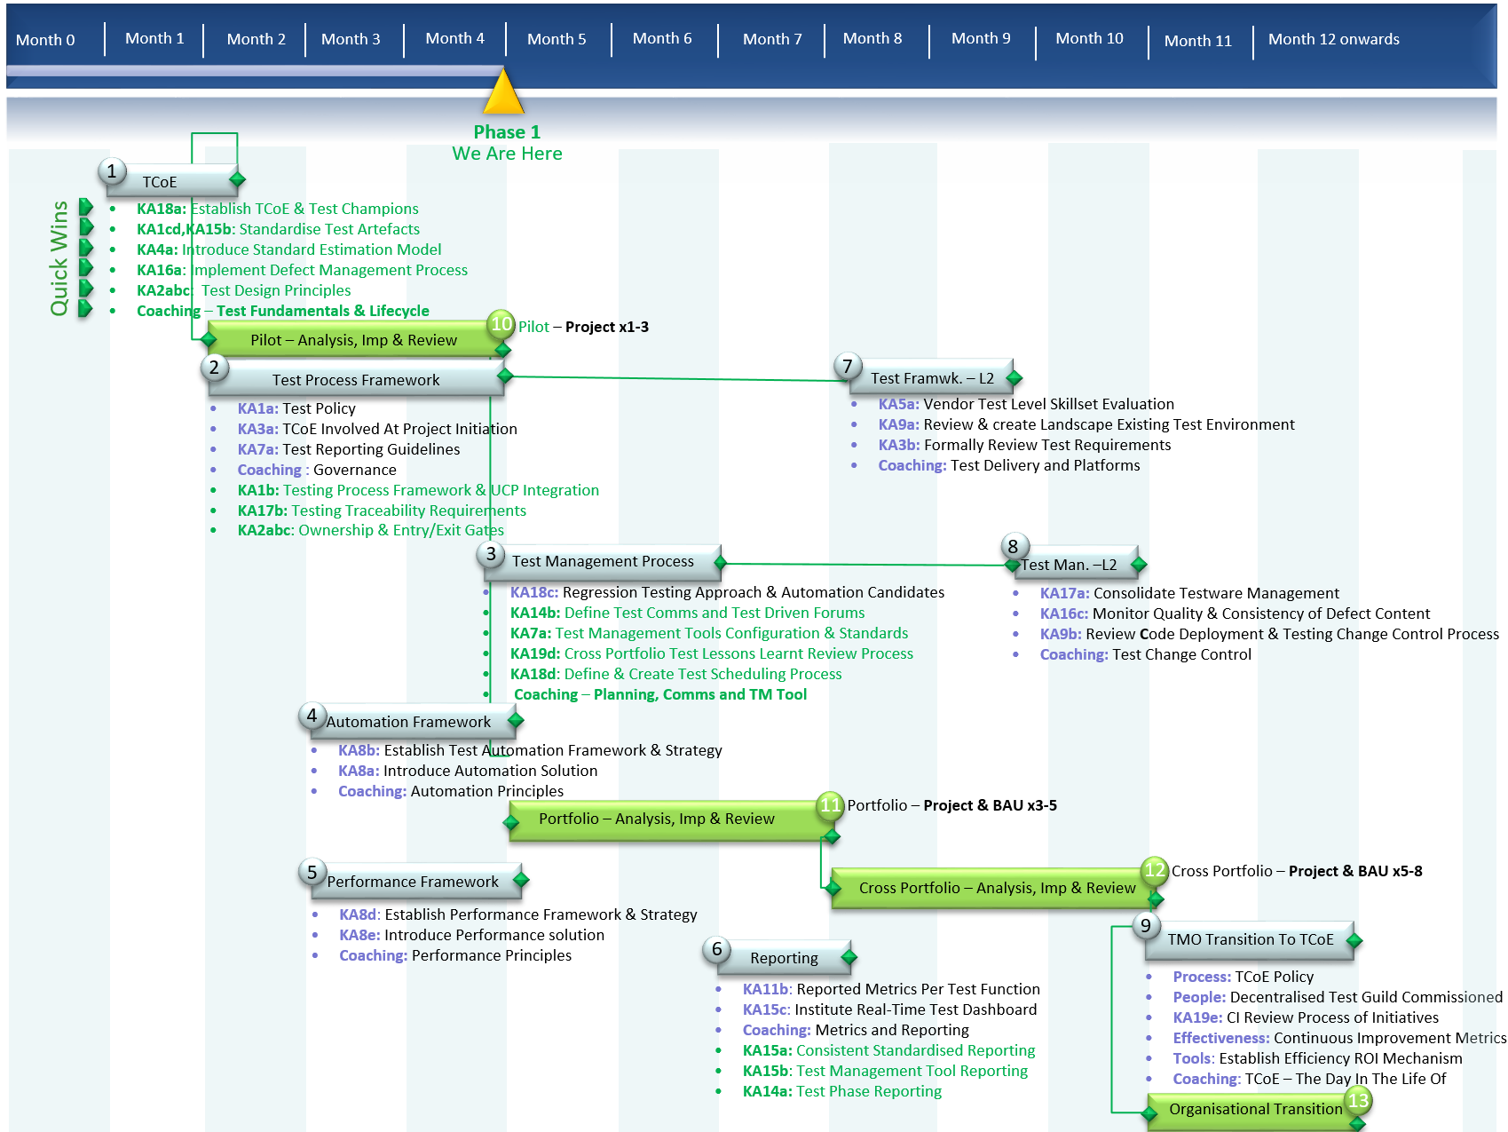

Planit have provided a targeted phase 2 optimisation approach as requested, however this should be refined based on Woodside’s feedback and measured against the current business objectives and uplift that Woodside are seeking to achieve in respect to testing. This approach has been refined based on Planit’s learnings from Phase 1. Planit recognises this approach will build and optimise upon the TCoE foundation established during phase 1. This drives the process and quality accelerators in order to deliver maximum benefit in the quickest time.

Following on from the successful pilot approach used in Phase 1 to provide fast feedback on the TCoE deliverables, Planit has also structured Phase 2 deliverables in this manner. This will enable commencing and inflight projects to trial and feedback on outputs of Phase 2.

## 10.2 Phase 2 Implementation Cost Model

The table below articulates the full costing per outcome, on a resource basis, to deliver this proposal.

| **Milestone** | **Deliverables** | **Resource Type** | **No of Days** | **Daily Rate**  **(Exc. GST)** | **Cost $ AUD**  **(Exc. GST)** |
| --- | --- | --- | --- | --- | --- |
|  |  | STM/TDM | 36  (18/18) | $ | $ |
| WBC | 10 | N/A | N/A |
|  | **KA18c:** Regression Testing Approach & Automation Candidates | STM/TDM | 24  (12/12) | $ | $ |
| WBC  **KA1a:** Test Policy  **KA3a:** TCoE Involved at Project Initiation  **KA7a:** Test Reporting Guidelines  **Coaching:** Governance and Assurance | 5 | N/A | N/A |
|  |  | STM/TDM | 22  (11/11) | $ | $ |
| WBC  **KA11b**: Reported Metrics Per Test Function  **KA15c**: Institute Real-Time Test Dashboard  **Coaching:** Metrics and Reporting | 5 | N/A | N/A |
| **KA8b:** Establish Test Automation Framework & Strategy  **KA8a:** Introduce Automation Solution  **Coaching:** Automation Principles  **KA8d**: Establish Performance Framework & Strategy  **KA8e:** Introduce Performance solution  **Coaching:** Performance Principles |  | TTDM | 53 | $ | $ |
| WBC | 5 | N/A | N/A |
|  |  | TTDM | 28 | $ | $ |
| WBC | 5 | N/A | N/A |
| **KA5a:** Vendor Test Level Skillset Evaluation  **KA9a:** Review Landscape Existing Test Environment  **KA3b:** Formally Review Test Requirements  **Coaching:** Test Delivery and Platforms |  | STM/TDM | 40  (20/20) | $ | $ |
| WBC | 5 | N/A | N/A |
| **Process:** TCoE Policy * Carry over from P1  **People:** Decentralised Test Guild Commissioned  **KA19e:** CI Review Process of Initiatives  **Effectiveness:** Continuous Improvement Metrics  **Tools**: Establish Efficiency ROI Mechanism  **Coaching**: TCoE – The Day In The Life Of | **KA17a:** Consolidate Testware Management  **KA16c:** Quality & Consistency of Defect Content  **KA9b:** ReviewCode Deployment & Test Change Control  **Coaching:** Test Change Control | STM/TDM | 28  (14/14) | $ | $ |
| WBC | 5 | N/A | N/A |
|  |  | STM/TDM | 45  22.5/22.5 | $ | $ |
| WBC | 15 | N/A | N/A |
|  | **Deliverables**   * **Portfolio:** [**3-5** Projects & BAU] * **-** Pilot Deliverables * **-** (**2**) Test Process Framework * **-** (**3**) Test Management Process (%) * **-** (**4**) Automation Framework * **-** (**5**) Performance Framework * **Cross Portfolio:** [**5-8** Projects & BAU] * **-** Pilot and Portfolio Deliverables * **-** (**3**) Test Management Process * - (**6**) Reporting Standardisation * - (**7**) Bi-Modal Framework L2 * - (**8**) Test Management Process L2 * **Organisational Transition:**  All Project and BAU * **-** Pilot, Portfolio & Cross Portfolio Deliverables * - (**9**) TCoE Embedded * **Inflight Coaching**: Across the entire implementation | STM/TDM | 10  (5/5) | $ | $ |
| WBC | 10 | N/A | N/A |
|  |
| **Total Woodside Resource** | Woodside Business Consultant (WBC) | | 65 | N/A | NA |
| **Total Planit Resource Cost** | Strategic Test Manager (STM) | | 102.5 | $ | $ |
| Test Delivery Manager (TDM) | | 102.5 | $ | $ |
| Technical Test Delivery Manager | | 81 | $ | $ |
| Planit have provided discounted rates for all resources detailed in the cost table as follows:   * **Strategic Test Manager/ Test Delivery Manager Std. Daily Rate:** $+GST, Woodside Rate $+GST (% discount)   Based on these discounts these provide Woodside a total value proposition saving of **$+GST ( % discount)** | | | | **Total Cost (Exc. GST)** | **$** |
| **Total Cost (Inc. GST)** | **$** |

## 10.3 Phase 2 Implementation Proposed Resource’s and Schedule

The proposed schedule is based on the activities quoted in the cost model above. It should be noted that the pilot phase will be a part-time parallel activity split between the STM/TDM working closely with the Woodside business consultants.

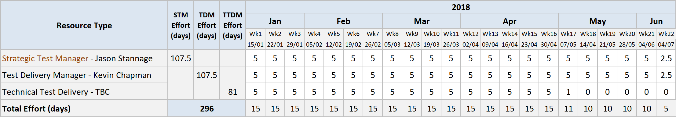

# Acceptance

Client Name: Woodside Energy

Client Recipient: Ling Heang /Allison Blaber

Proposed Services Acceptance Signed Date: _____________________________________________

|  |  |  |
| --- | --- | --- |
| Signed for and on behalf Woodside Energy |  | Signed for and on behalf Planit Test Management Solutions Pty Ltd |
|  |  |  |
| **Signature of authorised representative** |  | **Signature of authorised representative** |
|  |  |  |
| **Name of authorised representative** |  | **Name of authorised representative** |
|  |  |  |
| **Position of authorised representative** |  | **Position of authorised representative** |